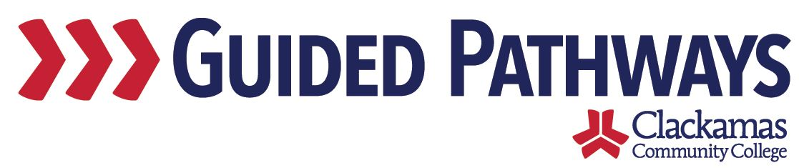
Guided Pathways Leadership Taskforce
Meeting Notes
May 4, 2020, 2:00–3:30 p.m. (Zoom)

- Follow up on previous commitments and updates
Introductions were provided.

Commitments were reviewed.
- Google Doc was created and shared last week
- Lupe sent out the FYE FAQ
- Tara invited the Title III director

- Update on early momentum metrics report
- Mark shared his screen, showing the early momentum metrics report: https://reports.clackamas.edu/Reports/report/Institutional%20Internal%20Reports/Early%20Momentum%20Metrics%20(Multi-Year%20TEST)
- Mark answered questions about the report.
- Mark and Lauren are working on a definitions page for the report.
- Will be accessible to everyone via the IR reports.
- Nora asked about targets/goals as a taskforce. Lisa Anh said that some of the Title III work that Kelly Love is leading speaks to the goals of guided pathways. There are some indicators established. David said that this is something that we will continue to work on. An agenda item for summer or early next year.
- If you have any questions or issues with the report, send those to Mark, Lauren, or Lisa Anh.

- GPTF timeline activity
- Max emailed a link to a document – CP Prioritization: Rubric Definitions: https://docs.google.com/document/d/15qjWYStEZZjsg0IiUcxmkxa76tWRVHb_f7aRAZtIzNg/edit?usp=sharing
- Three definitions that we’ll be going through
  - Urgency
  - Impact
  - Anticipated work time
- Carol discussed the work that has happened since the last meeting – looked at overlap and connections, made that into a list of things that we need to be working on – some things got combined – looked for gaps – clear overlaps where groups were thinking together – gaps, such as teaching and learning – came up with a list of the projects
- Max shared the GPTF 202-2021 Project Inventory: https://docs.google.com/spreadsheets/d/1qmeZORggn0o_Zb5QRwbv32Uut1ERfLnSaA24rw2TfSo/edit#gid=0
- Break into breakout rooms
- Each breakout group looked at the projects, scored according to the rubric
- Max explained that this inventory is multiplying urgency and impact and then dividing by work time
- Report outs
- Max said that there’s a group meeting on Friday with Jason to talk through these scores – take into consideration questions and make refinements
- Group 1
  - Questions about what was meant by create internal communications/case management system – thought it was important, but had different ideas of what it meant
  - Didn’t put anything in 4, as we already do program level curriculum review
- Group 2
  - Weren’t sure what to do with item 9
  - EFA requirements are already in progress – low-hanging fruit that we could accomplish fairly quickly
  - Didn’t think course review was urgent for this year
- Group 3
  - Need to wait for some of the work to unfold before assessing, so scored lower on that for this year
- Group 4
  - EFA level curriculum review – not high priority urgency
  - 20 and 22 look higher
  - Didn’t get to look at class scheduling
- Once the group has reviewed on Friday, they will make sure to send out the final list for one final review with the taskforce

- EFA Webpages
- Lori shared her screen to show a website update
- New EFA pages
- Academics Find your focus
- Swag – stickers for each EFA

- Workgroup updates
- Max suggested a conversation for our next meeting: discuss how we’re organized

- Review commitments and next steps
Commitments and next steps were reviewed. The next Guided Pathways Taskforce Meeting is on Monday, June 1, 2:00–3:30 p.m.

